Before you start, please:
- Insert the CS120 class USB Thumb drive
- On the USB root folder/directory, create the CS120 folder (unless the folder already exists)
- Under CS120, create Week10-Files folder (unless the folder already exists)
- Use USB-thumb-drive-letter:\CS120\Week10-Files to store all week five files
- Download Week10-Assignment.docx to Week10-Files folder
- Open the USB-thumb-drive-letter:\CS120\Week10-Files\Week10-Assignment.docx file, answer all questions, save the changes to the file, and upload to Moodle.

Q1) (1 point) Go to https://howsecureismypassword.net/ website and check how secure is your password:
- Type in the password you want to check (NOTE: You don’t need to type in your password! You could type another password with similar complexity to your password.)
- Use the Snipping tool to capture the HOW SECURE IS MY PAQSSWORD? window
- Use the red Pen to circle how long it will take to crack your password (1 point)
- Save as snip-1.jpg in Week10-Files folder.
Paste-snip-1-here
Q2) (1 point) Go to https://haveibeenpwned.com/ website and check if your email account has been compromised (you could test all of your email accounts):
- Type in the email account you want to check (NOTE: Will not prompt for password!)
- Use the Snipping tool to capture the Have I been pawned? window
- Use the red Pen to circle the answer (1 point)
- Save as snip-2.jpg in Week10-Files folder.
Paste-snip-2-here
Q3) (2 points) View your Windows Update history:
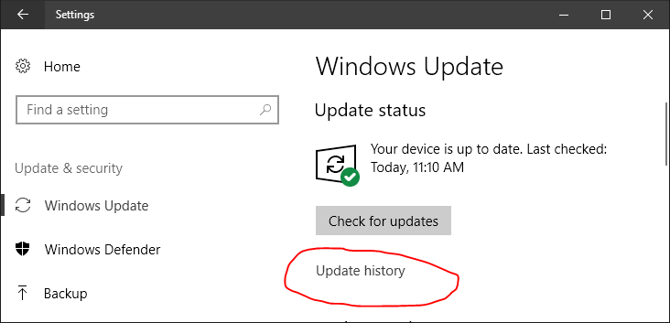
- NOTE: If you have not enabled Windows Update, the history will be empty. If this is the case, enable and run Windows Update first.
- Open the Windows Update window:
  - Click on the Start Screen button
  - Click on the Settings link
  - Click on Update & Security link
  - Click on Windows Update link (should be selected by default)
- Click on the Update history link
- Use the Snipping tool to capture the Update History window (1 point)
- Use the red Pen to circle the first update that starts with Security (1 point)
- Save as snip-3.jpg in Week10-Files folder.

Paste-snip-3-here
Q4) (2 points) Update and run your Anti-Malware/Anti-Virus application:
- Find out which Anti-Malware/Anti-Virus your computer is using
- Update the signature file/definition file
- Perform a quick or full scan
- Use the Snipping tool to capture the Anti-Malware/Anti-Virus window (1 point)
- Use the red Pen to circle that your computer is safe (NOTE: This will be different for the different Anti-Malware/Anti-Virus window applications (1 point)
- Save as snip-4.jpg in Week10-Files folder.
Paste-snip-4-here
Q5) (2 points) Configure the Windows Firewall to prevent others from accessing your computer:
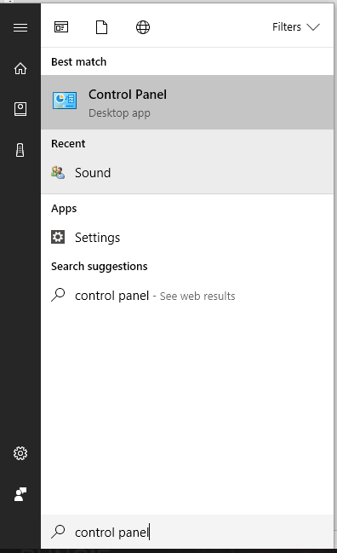
- Run the Windows Firewall utility:
  - Click on the Start Screen button and type Control Panel
  - Click on the Control Panel link
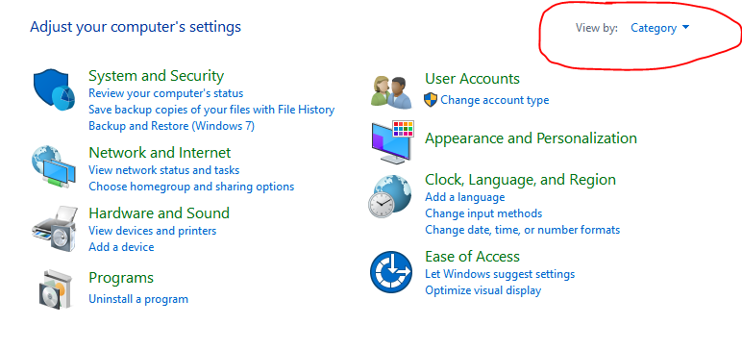
  - NOTE: Make sure the View by: is set to Category.
  - Click on the System and Security link
  - Click on the Windows Firewall link
- Click on the Turn Windows Firewall on and off link
- Select both Block all incoming Connections, including those in the list of allowed apps options
- Use the Snipping tool to capture the Windows Firewall window (1 point)
- Use the red Pen to circle the two changes you made (1 point)
- NOTE: If you allow others to access your computer over the network, then undo the changes you made.
- Save as snip-5.jpg in Week10-Files folder
Paste-snip-5-here

Q6) (2 points) Configure the Screen saver to lock your computer after 5 minutes of idle time:
- Open the Screen Saver window:
  - Click on the Start Screen button
  - Click on the Settings link
  - Click on Personalization link
  - Click on Lock screen link
  - Scroll down and click on the Screen saver settings link
- In the Wait: field, enter 5
- Select the On resume, display logon screen option
- From the Screen saver gallery/menu, select your favorite option
- Use the Snipping tool to capture the Screen Saver Settings window (1 point)
- Use the red Pen to circle the changes you made (1 point)
- Save as snip-6.jpg in Week10-Files folder
- Click on Done.
Paste-snip-6-here

