**Final Project Guideline**

**CS120**

**Travel Brochure**

**Before you start, please:**

1. The final project is a team exercises and the team is encouraged to use cloud storage to create and collaboratively work on all three documents.
2. After the team has created and finalized all three documents:
   1. Insert the CS120 class USB Thumb drive.
   2. On the USB root folder/directory, create the ***CS120*** folder (unless the folder already exists).
   3. Under ***CS120***, create ***FinalProject*** folder (unless the folder already exists).
   4. Use ***USB-thumb-drive-letter:\CS120\FinalProject*** to store files for this project.
3. Only a single student from each team needs to upload the three documents into Moodle (The instructor knows which students are on each team).

The Final Project is to test your understanding of what we learn in class using Microsoft Word, Excel and PowerPoint. Pretend you work for a tourism agency and you need to inform customers of an interesting destination. In order to inform and persuade your customers to want to visit this place, you decide to create a brochure about it. You will use Microsoft Word to create the brochure and Microsoft Excel to create table(s) and chart(s). The last part is to create a Microsoft PowerPoint presentation for your team to use during the in class presentation.

1. **Microsoft Word:**
2. Create a three-fold brochure.
3. The first column should include “Welcome to your-destination” or something similar to that. Insert a picture, from the Internet, below the text that would attract tourists to visit your country. After the picture provide a summary of the country, something that would interest the tourists. Use Times New Roman font, size 20 for “Welcome to …” heading. Use Times New Roman, size 12 for the country summary.
4. The second column is titled “Major Tourist Attractions:”. This is where you will list at least three major tourist attraction and provide information about each place. Insert pictures of the major tourist attraction after each heading and description. For the “Major Tourist Attractions:” and “Interesting Facts:” headers, use Times New Roman font, size 14, and Bold. For the description of each attraction, use Times New Roman Font style and size 12.
5. The third column is titled “Interesting Facts:”. This is where you will insert table(s) from Microsoft Excel and the associated chart(s). You may use column, bar, pie, or line charts.
6. Be creative and have fun with the assignment!

Microsoft Word Example:

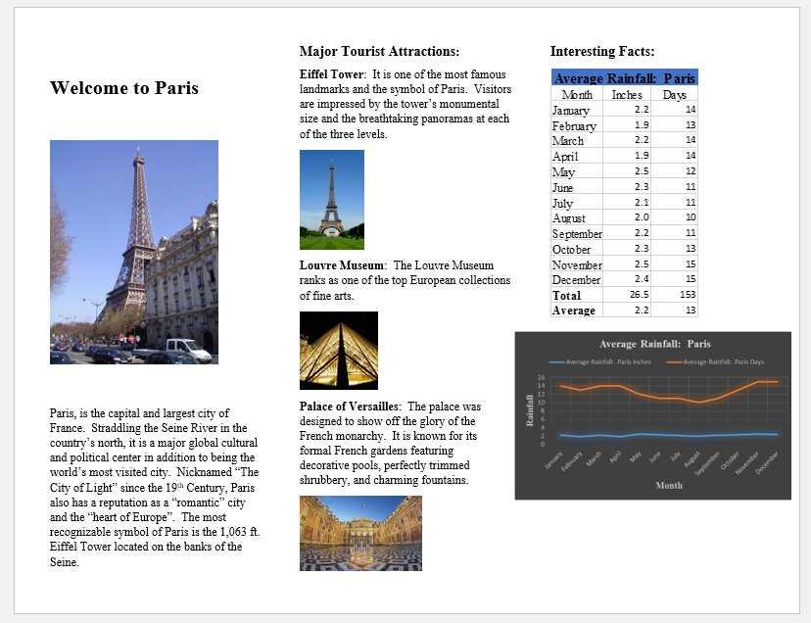

**Microsoft Excel:**

1. Determine the country data you want to collect and chart (i.e. average rain fall per months, average temperature per months, number of tourists per months or per site, cost of 3-star hotels, etc.) Make sure the data you collect is accurate and the best way to chart (columns, pie, line, etc.). Whatever you wish to collect and chart.
2. Create the MS Excel table(s).
3. Merge and Center the title of the worksheet. Use Times New Roman font, size 14, Bold and Blue, Accent 5 Fill.
4. Center and underline the data headings (i.e. Month, Inches, and Days). Use Times New Roman Font, size 12.
5. For the “Total” and “Average”, use Times New Roman, size 12, and bold.
6. Format the data properly, for example, the inches’ data format is number with one decimal and the Days format is number with no decimal.

Table Example:



1. Create the chart(s).
2. For the chart title, use Times New Roman font, size 14, and bold.
3. Make sure to label the X-axis and Y-axis. Use Times New roman, size 12.
4. Chart(s) should include a heading and legend.
5. Be creative and have fun with the assignment!

Microsoft Excel Chat Example:

1. **Microsoft PowerPoint:**
2. Choose the World Map Series theme and select the one that is similar to your country. For example, Paris would be the World Map Series Europe.
3. On the Title page and for the Title, use Times New Roman, size 44, and bold. For the Subtitle, include the names of the team members and class name. Use Times New Roman font, size 20.
4. Include pictures for Major Tourist Attraction.
5. Name of Country on Title Page, Major Tourist Attraction, Interesting Facts, Conclusion, Sources font size=40, style=Times New Roman.
6. No fewer than 8 slides and more than 10 slides.
7. Include a conclusion slide.
8. Include a Resources/References slide – to show the resources (books, journals, web sites, blogs, etc.) you used to gather your factual data.
9. Points will be subtracted for all errors – spelling, grammar, formatting, missing components, inaccurate data, etc.
10. Each team will be given up to 15 minutes to present their project to the class on Final Exam day. The presentation should not exceed 12 minutes with 2-3 minutes for Q&A.
11. Be creative and have fun with the assignment!

Microsoft PowerPoint Example:

