Before you start, please:
- Insert the CS120 class USB Thumb drive
- On the USB root folder/directory, create the CS120 folder (unless the folder already exists)
- Under CS120, create Week8-Files folder (unless the folder already exists)
- Use USB-thumb-drive-letter:\CS120\Week8-Files to store all week nine files
- Download Week8-Assignment.docx to Week8-Files folder
- Open the USB-thumb-drive-letter:\CS120\Week8-Files\Week8-Assignment.docx file, answer all questions, save the changes to the Week8-Assignment.docx file, then zip with MSExcel File-2.xlsx and upload to Moodle.

Q1) (5 points – subtract 1 point for each error) Start MS Excel and create a new spreadsheet that is identical to the one below. Spreadsheet guidelines:
- Font = Times New Roman for all
- Font size:
  - College Student Grocery List header: color = black, bold, and font size = 14, merge and center
  - Items, Quantity, Price and Total Price: color = black, bold, and font size = 12, underline, center
- Dollar values format = Currency
- Row 10 Total: fill color = Green, Accent 6
- Use the Sum function to add the totals
- Dollar value for Row 10 Total: bold, double underline
- Name each worksheet as follows: College Student Grocery List, Column Chart, Pie Chart
- Save as MSExcel File-2.xlsx in Week 8-Files folder

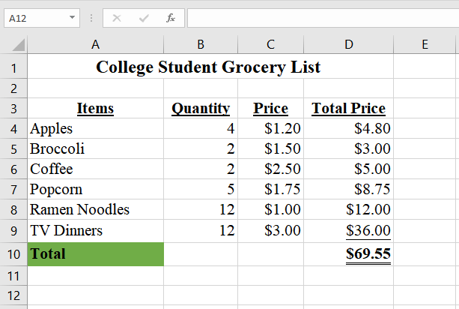

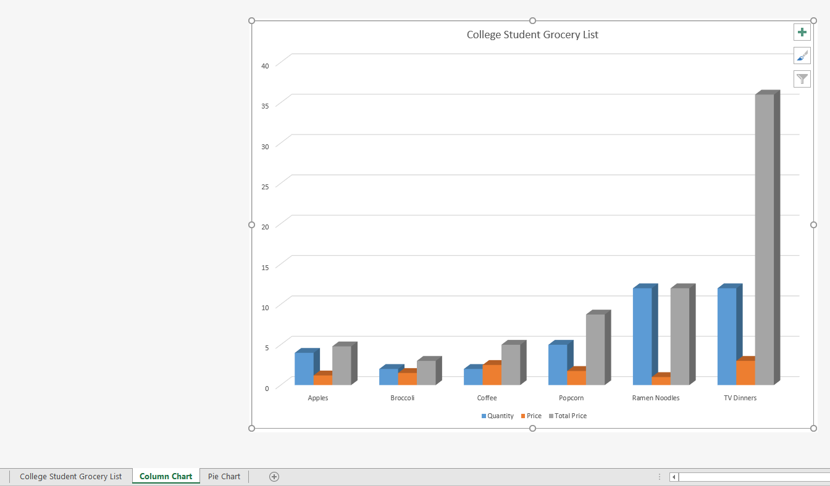

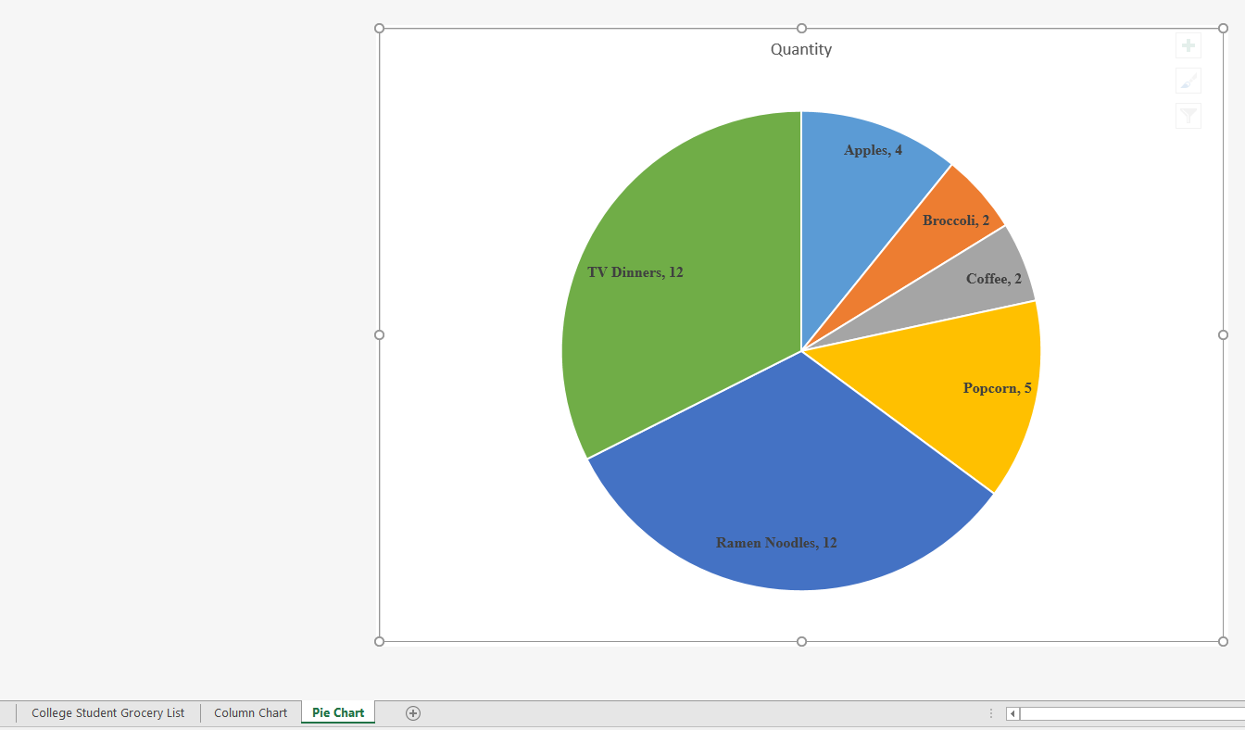

Q3) (5 points) Google Sheets:
- Open blank sheet in Google Sheets
- Save as GoogleSheet File-2 in LBCC\CS120 folder
- Times New Roman font
- Sheet title/subtitle (LBCC Tuition and Fees 2016-2017): Font-Times New Roman, size 12, bold, merge and center
- Category headers (credit, tuition only, etc.): Font-Times New Roman, size 12, bold, underline
- Total cost: fill color-green
- Create column and bar chart titled LBCC Tuition and Fees 2016-2017
- Click on the Sheet tab and snip the screen content
- Save as snip-1.jpg in Week8-Files folder
- Click on the Colum Chart tab and snip the screen content
- Save as snip-2.jpg in Week8-Files folder
- Click on the Bar Chart tab and snip the screen content
- Save as snip-3.jpg in Week8-Files folder
- Paste snip-1.jpg, snip-2.jpg, and snip-3.jpg below, at the very end, and continue with next step
- Zip both Week8-Assignment.docx and MSExcel File-2.xlsx Files
- Upload zipped file in Moodle.
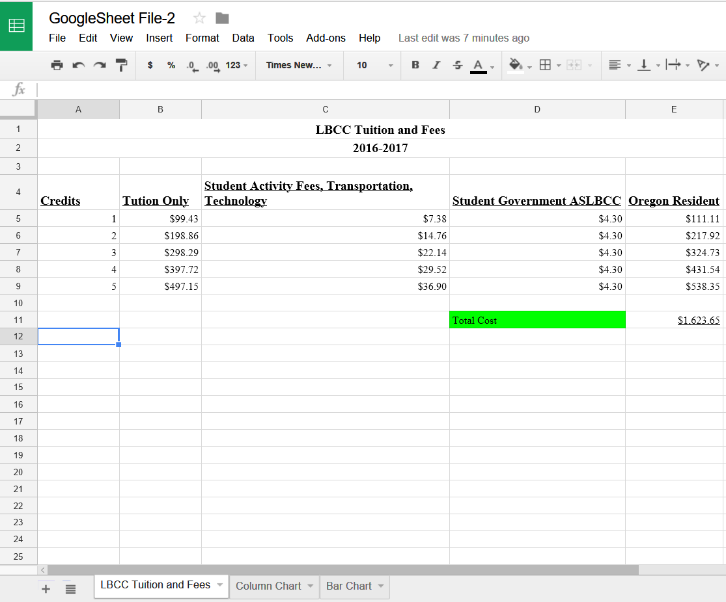
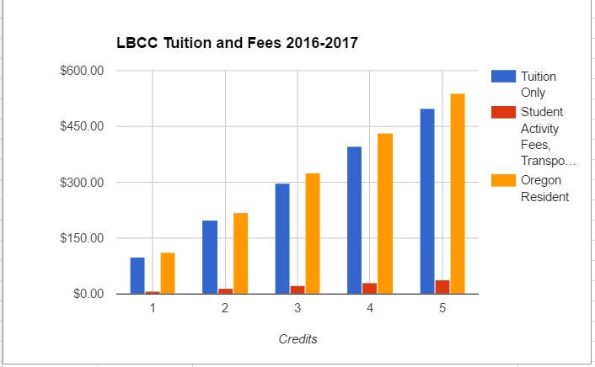
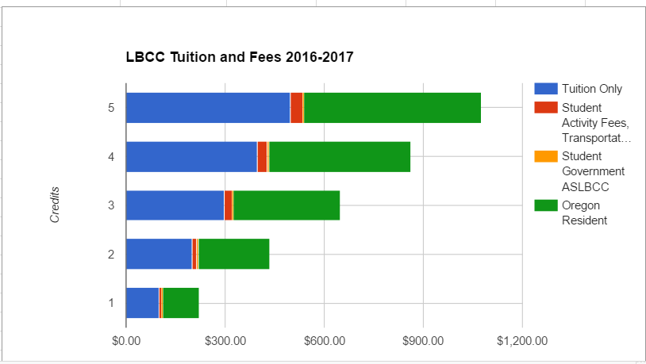

Paste-snip-1-here
Paste-snip-2-here
Paste-snip-3-here

