Before you start, please:
- Inset the CIS101 class USB Thumb drive
- On the USB root folder/directory, create the CIS101 folder (unless the folder already exists)
- Under CIS101, create Week10-Files folder (unless the folder already exists)
- Use USB-thumb-drive-letter:\CIS101\Week10-Files to store all week seven files
- Download Week10-Assignment.docx to Week10-Files folder
- Open the USB-thumb-drive-letter:\CIS101\Week10-Files\Week10-Assignment.docx file, answer all questions, save the changes to the file, and upload to Moodle.
- IMPORTANT: This assignment will require you to use a Microsoft OneDrive account. If you don’t have a Microsoft OneDrive account, please create one now - https://onedrive.live.com/about/en-us/.

Q1) (7 points – subtract 1 point for each error) Start MS PowerPoint, on the New/Templates screen, click on Blank presentation and create a new file with the following three slides (minus the tiled slide background):
Guidelines:
- Use the Facet theme with blue variation
- Make sure to enter the Notes one slide-1 and slide-2
- For the graphics/pictures, search online pictures:
  - For slide-1, search for MS Office
  - For slide-2, search for pros and cons
  - For slide-3, search for two thumbs up
  - NOTE: If you can’t find the exact picture, use a similar picture.

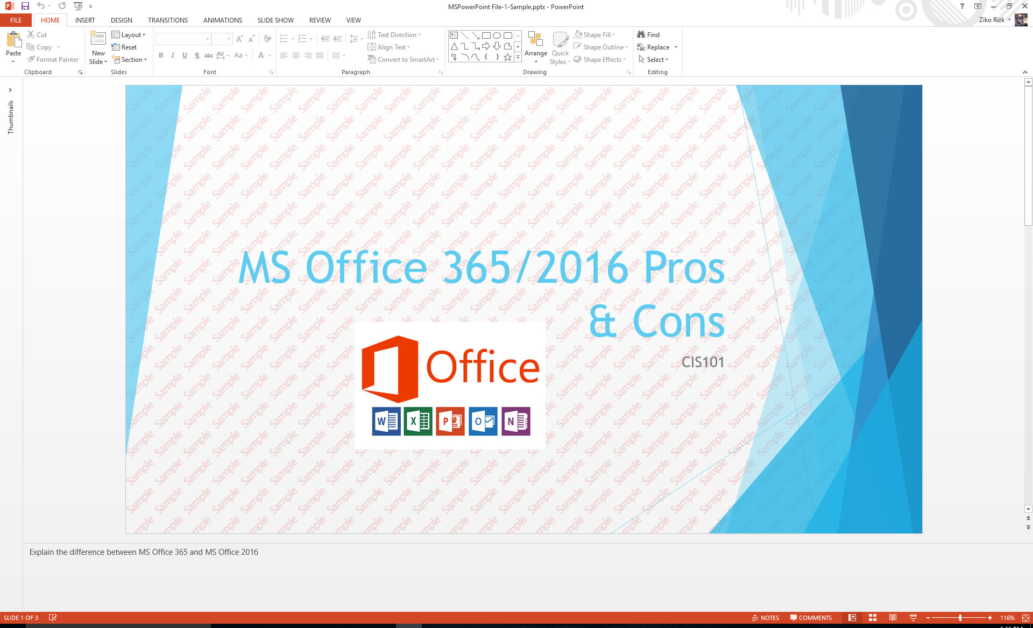

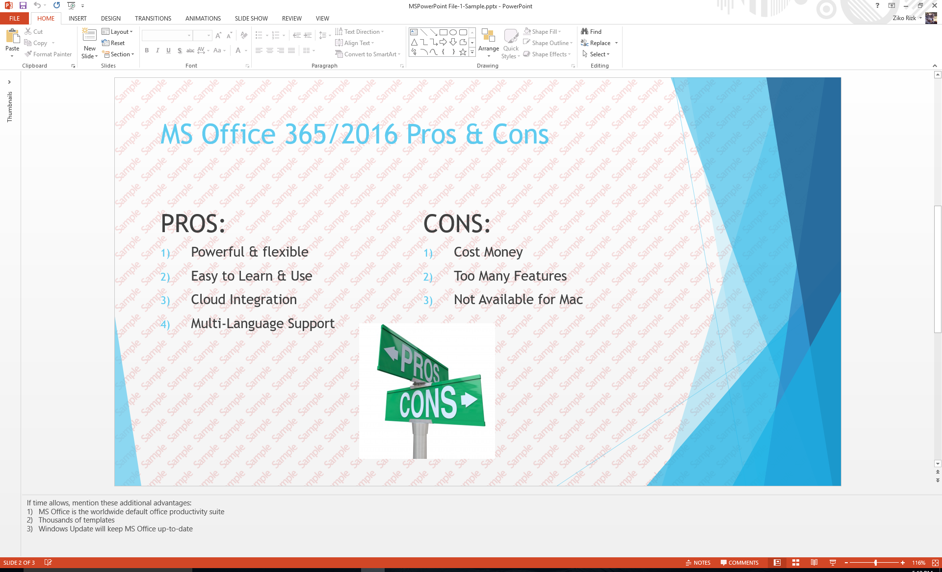

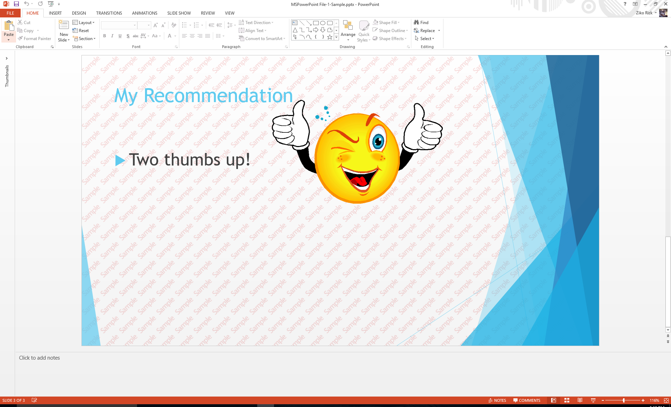

- Save as MSPowerPoint File-1.pptx in Week10-Files folder
- Select the first slide
- Maximize the Slides/navigation pane (manually to enlarge the three slides)
- Snip the entire PowerPoint window
- Save as snip-1.jpg in Week10-Files folder.
Paste-snip-1-here
Q2) (3 points – subtract 1 point for each error) Create the above slides using Microsoft OneDrive PowerPoint:
- Logon to OneDrive using your Microsoft account
- From the navigation pane, click one Files and create \LBCC\CIS101 folders
- From the menu, click on New, then click on PowerPoint Presentation
- Create the above slides using the same guidelines
- Save as MSPowerPoint File-1 in LBCC\CIS101
- Select slide first slide
- Use the red Pen to circle the file name, MSPowerPoint File-1, and the notes at the bottom of the screen
- Snip the entire screen
- Save as snip-2.jpg in Week10-Files folder.
Paste-snip-2-here

