Before you start, please:
- Insert the CS120 class USB Thumb drive
- On the USB root folder/directory, create the CS120 folder (unless the folder already exists)
- Under CS120, create Week9-Files folder (unless the folder already exists)
- Use USB-thumb-drive-letter:\CS120\Week9-Files to store all week ten files
- Download Week9-Assignment.docx to Week9-Files folder
- Open the USB-thumb-drive-letter:\CS120\Week9-Files\Week9-Assignment.docx file, answer all questions, save the changes to the Week9-Assignment.docx file, then zip with MSPowerPoint File-1.pptx and upload to Moodle.

Q1) (5 points – subtract 1 point for each error) Start MS PowerPoint and create a presentation about what you learned in week 9:
- On the New/Templates screen, click on Berlin and select the green variation
- Create a PowerPoint presentation with identical formatting to the one below
- Slide guidelines, total of 5 slides:
  - Slide 1 - What I learned in Week 9
  - Slide 2 - Creating and Opening Presentations (In your own words, enter 3 bullet items)
  - Slide 3 - Saving and Sharing Presentations (In your own words, enter 3 bullet items)
  - Slide 4 - Inserting Pictures (In your own words, enter 3 bullet items)
  - Slide 5 - Conclusion (In your own words, write a concluding paragraph about the three topics)
- For the graphics/pictures, search online pictures:
  - For slide-2, search for powerpoint
  - For slide-3, search for save powerpoint document
  - For slide-4, search for insert picture document
  - NOTE: If you can’t find the exact picture, use a similar picture.
- Save as MSPowerPoint File-1.pptx in Week9-Files folder.

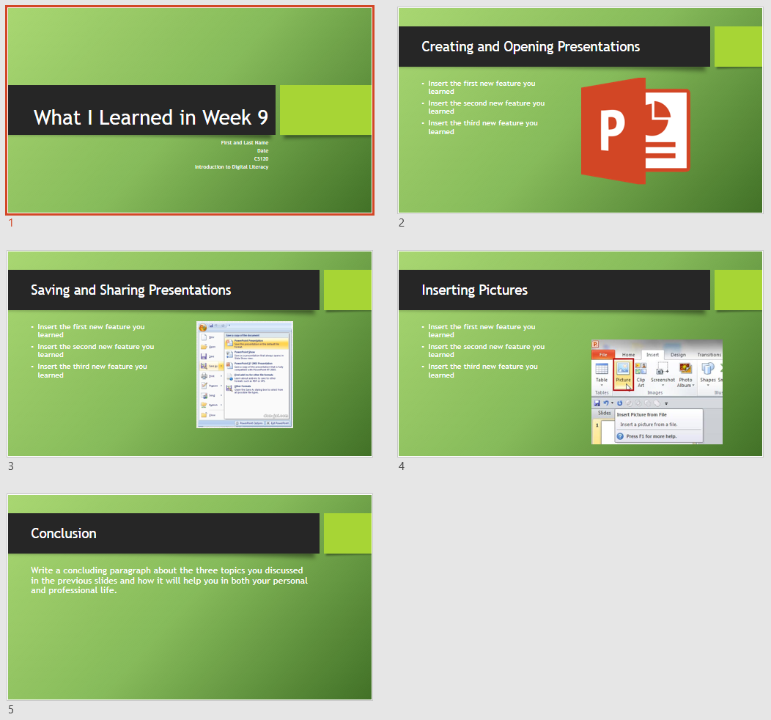

Q2) (5 points – subtract 1 point for each error) Start Google Slides and create a presentation about what you learned in this course:
- Open blank slides in Google Slides
- Select Material for Theme
- Save as GoogleSlides File-1 in LBCC\CS120
- Create a slide on your course goals (three things you learned as a result of this class) and insert a picture for each topic. The picture should relate to the topic. For the topic slides, include text about what new things you learned and how it will help you in the future.
- Slide 1 – Title slide (Course Goals, CS120 Introduction to Digital Literacy)
- Slide 2 – Topic 1 (In your own words, select and write a paragraph about the topic you have learned in this course.)
- Slide 3 – Topic 2 (In your own words, select and write a paragraph about the topic you have learned in this course.)
- Slide 4 – Topic 3 (In your own words, select and write a paragraph about the topic you have learned in this course.)
- Slide 5 – Conclusion (In your own words, write a concluding paragraph about the three topics you have learned in this course.)
- Click on the grid view (similar to Slide Sorter in PowerPoint) to view all the slides in one page.
- Use the Snipping tool to take a screen capture (of all 5 snips)
- Save as snip-1.jpg in Week9-Files folder
- Paste snip-1.jpg below, at the very end, and continue with next step
- Zip both Week9-Assignment.docx and MSPowerPoint File-1.pptx files
- Upload zipped file in Moodle.
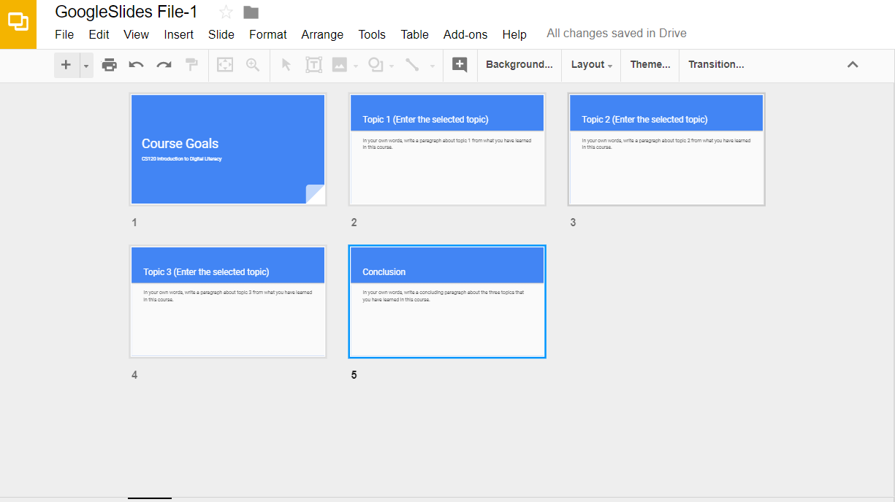

Paste-snip1-here:

