CREATIVE Lesson Plan
Subject: Sciences Instructor:
Grade: Materials Needed: Flash Cards
0bjective:
Students will be able to (SWBAT) work in teams to create and identify land masses.
 | TEACHER PROCEDURE | STUDENT ACTIVITIES | PURPOSE OF ACTIVITY
5 min | Warm up:  Students sit in a-circle on the floor: Briefly discuss aspects of unit previously covered | Students identify the elements which make up the different land masses and how created | Mentally prepare and stimulate for upcoming exercise
5 min | Warm up #2:  Pass out visuals that each group found during computer lab  Ask to identify form and any other observations | 'Neutral' is a physical position: Standing with arms hanging loosely to the side, feet apart (the same distance as shoulders) hips evenly placed above thighs (no hip shifting) head sits evenly atop the neck No expression on face but relaxed. At no .time should the student feel stiff as though standing at attention. | 'Neutral' is a calming but gives the students the idea that something important is going to take place. It also puts the student in control of his or her own body. It is a position of readiness.
10 min | Transition:  Twizzle, a focus game. Call out cues while •students walk around in a circle.  The 'cues' are:  Go: walking around the circle Turn: stop and turn facing in the opposite direction  Jumpzump up in the air and land facing the opposite direction Twizzle: jump up turn 360 degrees and land facing in the same direction. | There is no talking at anytime during this game or else it counts as an 'out' and the student sits in the center of the circle.  When -the teacher calls out a cue then the student responds and stays frozen until the next cue. If students moves while in a frozen state than that counts as an 'out'. When a cue is executed improperly then that student is 'out' and sits in the center of circle, until only one student remains as the winner. | This game is highly successful in achieving total focus both physically and mentally. Students must listen while moving and react the moment a cue is heard. The first time this game is played several •practices' may need to be played to get the students prepared but once the objective is clear this game becomes like candy or a reward.  FOT younger ages a modification of the cues: jump and twizzle can be made. Jump: jump up in air and land facing same direction. Twizzle: jump up in air land in. opposite direction.

 | TEACHER PROCEDURE | STUDENT ACTIVITIES | PURPOSE OF ACTIVITY
15  •min | Machines  Students create a machine. While sitting in the same circle ask students if they have seen the inside of a machine: car, clock, radio, etc.  What they saw are small parts working together to create a machine. Demonstrate with sounds: one student starts as others join in going around the circle. Then begin by asking them to create movements with their body while remaining stationary. | One student begins by creating a sound and movement that is repetitious; gradually students come into the circle to attach their machine part (which also moves sound) until the entire class has created a one huge machine | Cooperation within a group sharing and connecting with one another.  A time limit helps in avoiding over analyzing and control issues-  Students should add to the machine as quickly as possible.  This exercise can go one step further by breaking up in to teams of 4 to 6 and asking that each group create a machine to share with the class. Students take turns guessing what kind of machine was created
20 min | Unit Study: Sciences  Land Masses  Remind students of the unit being studied Count off into groups of 5-7. After each group is separated and in a separate area of the classroom ask one student from each group to come and choose a 'card'. On the cards are listed land masses that have been studied. The students work quietly in their group for only a few minutes then are asked to sit in their groups and wait to share.  After evaluation ask students to create one physical representation of all the land masses by strategically placing each group in one area but attached. | Students work together to physically create land masses as listed on the card  After completion they sit and wait to share with classmates. Each group demonstrates their work and the class guesses •which •land mass was being represented. | Students become physically engaged with the science unit bringing to life all the aspects involved. Students learn to evaluate and make thoughtful contributions to complete the lesson.  Questions are asked regarding important components to each land mass, was everything represented? What worked and what could be improved upon?
5 min | Cool Down:  Ask students to slowly collapse to the floor (counting down from 15) until spread out and I. | Students slowly collapse -to floor. Breathing exercise and come to a sitting position. Discuss experience wnesson.  Students then in -ournals. | Allows students to release that portion ofthe lesson and bring a close to the session
Landform Information
Mountains
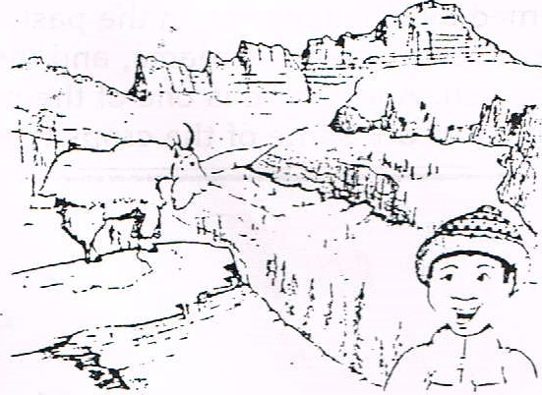
Mountains are natural landforms that reach high above the surrounding country. Thus, any part of Earth's surface that stands much higher than the surrounding land may be called a mountain. The height of a mountain is usually expressed as the distance that its peak rises above sea level. Mountains are a major feature of the landscape in many areas. The highest mountain in the United States, Alaska's Mount
McKinley, is more than 20,000 feet above sea level.
Mountains generally have steep slopes with sharp or slightly rounded peaks. A mountain may be a single peak, such as a lone volcano, or it may be part of a mountain range.
Streams and rivers often carve out valleys in mountains. Some mountain valleys are wide, especially in
Alder mountains; in the younger mountains, they are sually narrower. In time, mountains are worn down to the level of hills and plains.
Mountain ranges are important because they affect the climate and water flow of surrounding regions. Mountains are also important for the plants and animals they support and as a source of lumber and minerals. Much of the world's mineral resources come from mountainous regions.
Mountains are also important recreation areas. Each year, millions of people vacation in mountainous areas to camp, hike, ski, climb, or just to enjoy the fresh air and beautiful views.
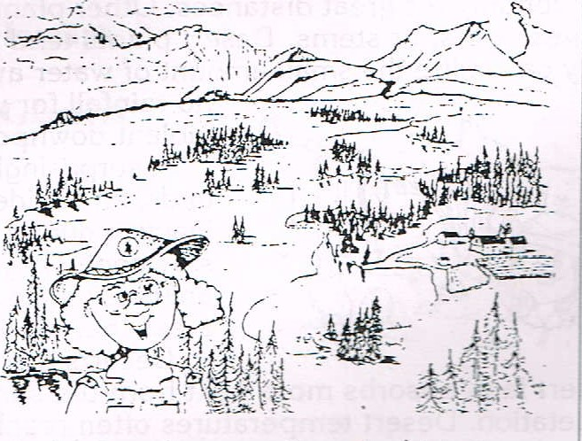
Valleys
A valley is a depression in the Earth's surface. Most valleys are formed by the running water of streams and rivers and by the erosion of slopes leading to them. Rock and soil material is eroded from the slopes of mountains and then moved to the valley floor. A valley may also be formed when a long, narrow section of Earth's crust sinks below the surrounding area.
The bottom of the valley is called its floor.
Mountain valleys usually have narrow floors, but low-lying plains, a floor may be several miles wide. The floors of valleys often have very fertile soil which makes excellent farmland. Many different crops are grown on fertile valley floors.
IMARILY EARTH 3 0 1996 AIMS Education Foundation
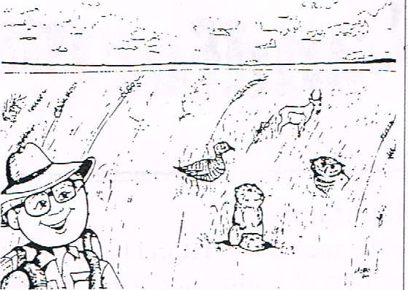
Plains
Plains are areas that are mostly flat. They are large regions that are quite level or have gently rolling hills with grasses and few trees. The interior plains of the United States were formed as mountains and hills but have been gradually worn down by wind, water, and glaciers.
These central plains have relatively good soil and are used for farming. In the United States, wheat, barley, and oats are some of the crops that grow on the plains.
Cattle and sheep are raised in these areas, too.
There are low flat plains along the coasts of the dnited States. These plains were formed by soil deposits. In the past, shallow oceans covered this area. Soil has been deposited by rivers, streams, and the ocean. The soils of the coastal plains are usually very rich. Agriculture is one of the main activities on coastal plains. Cotton, vegetables, and citrus are some of the crops that are grown in these areas.

Deserts
A desert is a region that receives less than 10 inches of precipitation each year. Deserts have many different landscapes and types of soil. Sand covers about one-fourth of the desert land; gravel-covered hills, mountains, and lowlands cover the rest of the desert landscape. Many kinds of plants and animals flourish in the desert. The plants and animals that are able to live in these harsh environments have adapted to these conditions.
Desert plants have adapted to the extreme dryness of the weather in various ways. Some have roots that go down a hundred feet or more, others have roots that spread out horizontally for great distances. Other plants store large amounts of water in their leaves, roots, or stems. Desert plants tend to be sparsely spread out over a large area so they can utilize the small amount of water available. Quite often a desert area will receive no rainfall for years, then a big storm will release a brief, violent downpour of rain.
A surprisingly large number of animals, insects, reptiles, birds, and spiders live in the desert. Most desert animals are inactive during the day, staying in shady areas or burrows to stay cool. They come out at night to feed and hunt. These animals obtain water from the food they eat and from the few areas that have water holes.
Deserts are some of the hottest places on Earth. The desert land absorbs more heat from the sun than areas which are covered with thick vegetation. Desert temperatures often reach 100 ⁰ F or higher during the day and may then drop 50 ⁰ at night.
Many desert soils are rich in minerals and in some areas, oil and natural gas.

PRIMARILY EARTH 4 0 1996 AIMS Education Foundation
Ze ans rhe ocean is a great body of salty water that covers more than 70 percent of Earth's surface. Almost all the water on Earth is in the ocean. The waters of the ocean form one great connected body; however, the continents divide this great body of water into four major parts. They are, in order of size, the Pacific Ocean, the Atlantic Ocean, the Indian Ocean, and the Arctic Ocean.
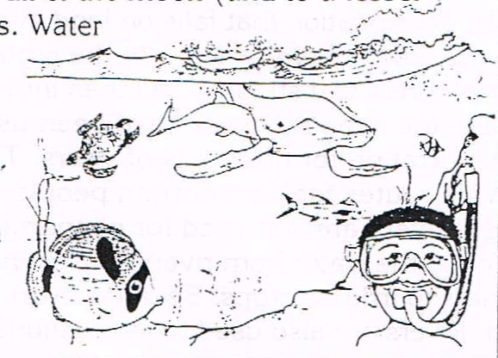
The waters of the ocean are moved around by the forces created by Earth's rotation and the heat of the sun. Tides, created by the gravitational pull of the moon (and to a lesser degree, the sun) also affect the movement of the oceans. Water leaves the surface of the ocean by evaporation and is later condensed forming clouds, only to eventually return as precipitation.
The ocean provides us with many things. It is a source of food, energy, and minerals. The waters of the ocean are used for transporting humans and cargo from port to port. We use the shores of the oceans as a place for swimming, boating, and other forms of recreation.
Lakes
A lake is a body of water surrounded by land. Lakes can be found in all parts of the world. The word lake comes from a Greek word meaning hole or pond. Lakes are usually deep depressions in the crust of the Earth that have filled with fresh water. Rain, melting snow, water from springs and rivers, and surface runoff fill these depressions.
The largest number of lakes lies in regions that were once covered by glaciers. In many mountains, the glacial ice carved deep valleys. The basins that were created filled with water. On the flatter land, glaciers gouged hollows in the land and deposited rocks and soil as they melted. Many lakes formed in these hollows and holes that were created by glacial deposits.
Lakes can form in regions where limestone underlies the soil. dnderground water slowly dissolves the limestone rock. When the surface collapses, a sinkhole will form and fill with water forming beautiful crystal clear lakes.
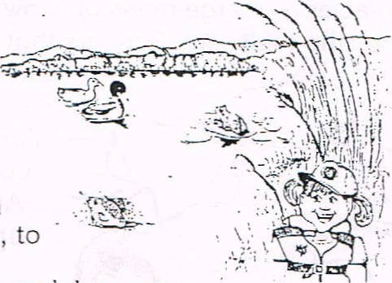
Many artificial lakes have been formed by building dams across rivers to control the runoff of water. These dams are built for several reasons: to protect the surrounding area from floods, to provide a source of water for drinking and irrigation, to provide water to generate electricity, and for recreation.
The economic uses of lakes are numerous. Some of the larger lakes are ed as travel and trade routes. Raw materials and other products are carried by boats the lakes to industrial centers. Lakes provide an important source of water for irrigation. They are a natural reservoir of water for communities. Lakes created as storage reservoirs can be used to generate electric power. People use lakes for a variety of recreational activities such as swimming, boating, fishing, and water skiing.
d cati o
Rivers
A river is a natural moving stream of fresh water. It is pulled downhill by gravity across the land. The flow of the river plays a role in the water cycle. With this cycle, water goes from the sea to the land and back again. Precipitation that falls on land evaporates back into the atmosphere, soaks into the ground, or runs off into rivers and streams and then into the ocean.
Like the oceans, rivers have been used for transportation for hundreds of years. Their waters provide routes for transporting people, their tools, food, and other necessities of life.
Larger rivers are still used for economical transportation of goods and people.
Today the water from rivers is used in the cities for the people to drink. It is used by the farmers to irrigate crops. Because rivers often contain edible fish, they serve as a supply of food. Rivers are also used for recreational fishing, boating, water skiing, and swimming.

Icecaps and Glaciers
Snow that falls on land melts to form runoff. However, there are places on Earth where it is too cold for all the snow to melt. As the snow falls year after year, it piles up. The weight of the snow compacts it and it becomes ice. It is estimated that approximately 75 percent of all the freshwater on Earth is in the form of ice. The polar regions are almost completely covered by ice.
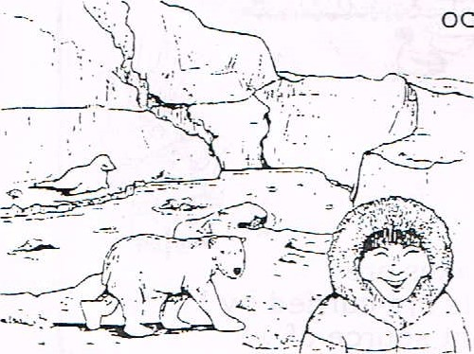
A glacier is a large mass of snow and ice that forms when the rate of accumulation exceeds the melt rate. Glaciers that cover large areas of land are called icecaps. Icecaps occur in places where the climate stays cold all year. An icecap must have land under it. Icecaps cover most of
Antarctica and Greenland. At the North Pole there is no continent and the ice sinks and melts under pressure. At the South Pole there is a continent so ice has built up and created an icecap.
Edges of icecaps and glaciers break off when they reach the sea. These huge pieces of ice float away as icebergs.
PRIMARILY EARTH 60 1996 AIMS Edication Foundation

VOCABULARY
Land Forms

Mountains | Oceans  Pacific
Region | Atlantic
Valleys | Arctic
Eroded  Plains | Indian
Fertile | Depression
Agriculture | Rivers
Interior | Precipitation
Deserts | Evaporate
Lowlands | Icecaps
Vegetation

