Before you start, please:
- Insert the CS120 class USB Thumb drive
- On the USB root folder/directory, create the CS120 folder (unless the folder already exists)
- Under CS120, create Week7-Files folder (unless the folder already exists)
- Use USB-thumb-drive-letter:\CS120\Week7-Files to store all week eight files
- Download Week7-Assignment.docx to Week7-Files folder
- Open the USB-thumb-drive-letter:\CS120\Week7-Files\Week7-Assignment.docx file, answer all questions, save the changes to the MSExcel File-1.xlsx and upload to Moodle.

Q1) (5 points – subtract 1 point for each error) Start MS Excel, on the New/Templates screen, click on Blank workbook and create a spreadsheet that is identical to the one below. Spreadsheet guidelines:
- Font = Times New Roman for all size 12
- Font color and size:
  - College Expenses for Four Years header: color = black, bold, and font size = 15, merge and center
  - Expense category headers: color = black, bold, and font size = 12 and underline
  - Year category headers along with totals and average: color = black, bold, and font size = 12
- Dollar values format = Currency
- Center expense category headers and expense values
- Select all borders for cells B4:F7
- Put a thick outside border A3:G9
- Use Gold, Accent 4 fill color for cells A1:G1
- Use Green, Accent 6 fill color for cells A8:G8
- Double underline cell G8 and single underline G7
- Use the Sum function to add the Totals
- Use the Average function to calculate the Average
- Save as MSExcel File-1.xlsx in Week7-Files folder
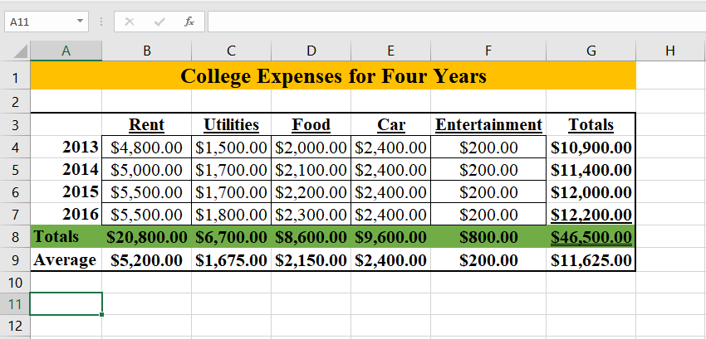

Q2) (5 points – subtract 1 point for each error) Start Google Sheets and produce the same spreadsheet as above with same guidelines:
HINTS: If you don’t find the exact function you used in MS Excel, use a similar Google
Sheets function.
- Save as GoogleSheet File-1 in LBCC\CS120 folder
- Snip the file content (including header and footer)
- Save as snip-1.jpg in Week7-Files folder.
- Paste snip-1.jpg, at the very end, and continue with next step
- Zip both Week7-Assignment.docx and MSExcel File-1.xlsx files
- Upload zipped file into Moodle.
Paste-snip-1-here

