Before you start, please:
- Inset the CIS101 class USB Thumb drive
- On the USB root folder/directory, create the CIS101 folder (unless the folder already exists)
- Under CIS101, create Week8-Files folder (unless the folder already exists)
- Use USB-thumb-drive-letter:\CIS101\Week8-Files to store all week seven files
- Download Week8-Assignment.docx to Week8-Files folder
- Open the USB-thumb-drive-letter:\CIS101\Week8-Files\Week8-Assignment.docx file, answer all questions, save the changes to the file, and upload to Moodle.

Q1) (10 points – subtract 1 point for each error) Start MS Excel, on the New/Templates screen, click on Blank workbook and create a spreadsheet that is identical to the one below (minus the at top-right):
Guidelines:
- Font = Times New Roman for all
- Font size:
  - Pam’s 2016 Expenses header, in black, bold and size = 15
  - Expense category headers and month, in black, bold and size = 12
- Dollar values format = Currency
- Center expense category headers and expense values
- Select similar colors – don’t have to be identical
- Use the Sum function to add the totals
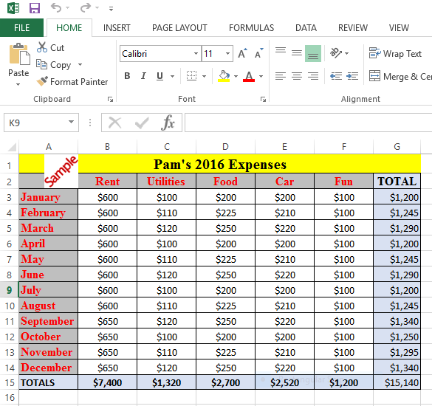

- Save as MSExcel File-1.xlsx in Week8-Files folder
- Snip the file content
- Save as snip-1.jpg in Week8-Files folder.
Paste-snip-1-here

