Before you start, please:
- Inset the CIS101 class USB Thumb drive
- On the USB root folder/directory, create the CIS101 folder (unless the folder already exists)
- Under CIS101, create Week9-Files folder (unless the folder already exists)
- Use USB-thumb-drive-letter:\CIS101\Week9-Files to store all week seven files
- Download Week9-Assignment.docx to Week9-Files folder
- Open the USB-thumb-drive-letter:\CIS101\Week9-Files\Week9-Assignment.docx file, answer all questions, save the changes to the file, and upload to Moodle.

Q1) (8 points – subtract 1 point for each error) Start Google Sheet and create a spreadsheet that is identical to the one below (minus the at top-right):
Guidelines:
- Font = Times New Roman for all
- Font size:
  - Pam’s 2016 Expenses header, in black, bold and size = 15
  - Expense category headers and month, in black, bold and size = 12
- Dollar values format = Currency
- Center expense category headers and expense values
- Select similar colors – don’t have to be identical
- Use the Sum function to add the totals
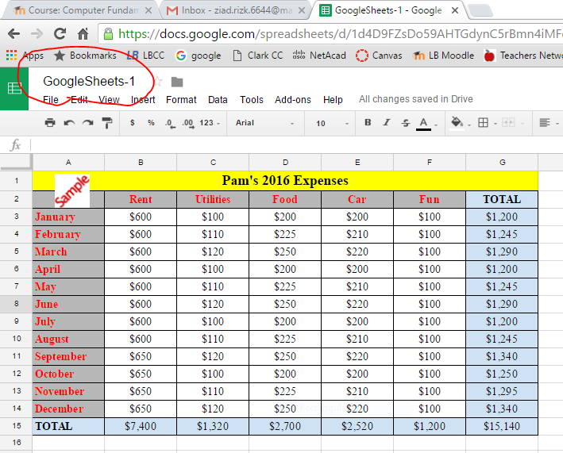

- Save as GoogleSheets-1 in LBCC\CIS101 folder
- Snip the file content
- Use the red Pen to circle the GoogleSheets-1
- Save as snip-1.jpg in Week9-Files folder.
Paste-snip-1-here
Q3) (2 points) Change the GoogleSheets-1 document permissions so anyone on the Internet Can comment the document:
- Right-click on GoogleSheets-1
- Click on Share
- Click on Advanced
- Click on Change under Who has access
- Select On – On public on the web
- From the Access drop-down menu, select Can comment, then click on Save
- Use the Snipping tool to capture the permission window
- Use the red Pen to circle the document permissions under Who has access
- Save as snip-2.jpg in Week9-Files folder
- Click on Done.
Paste-snip-2-here

