Before you start, please:
- Inset the CIS101 class USB Thumb drive
- On the USB root folder/directory, create the CIS101 folder (unless the folder already exists)
- Under CIS101, create Week7-Files folder (unless the folder already exists)
- Use USB-thumb-drive-letter:\CIS101\Week7-Files to store all week seven files
- Download Week7-Assignment.docx to Week7-Files folder
- Open the USB-thumb-drive-letter:\CIS101\Week7-Files\Week7-Assignment.docx file, answer all questions, save the changes to the file, and upload to Moodle.

Q1) (5 points – subtract 1 point for each error) Start MS Word, on the New/Templates screen, click on Blank document and create a file that is identical to the one below (minus the SAMPLE background):
Guidelines:
- Font = Times New Roman for all
- Font size:
  - Text, in black = 12
  - Category headers, in blue= 14
  - Page header and footer, in purple = 14
- Category headers, Header and Footer are bold
- No space between category headers and text
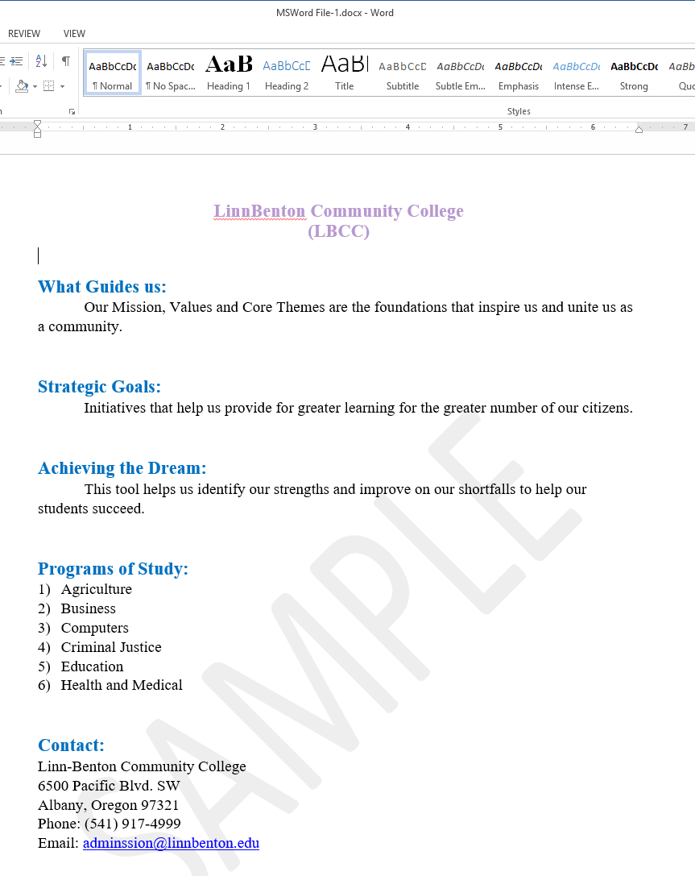
- Save as MSWord File-1.docx in Week7-Files folder
- Snip the file content (including header and footer)
- Save as snip-1.jpg in Week7-Files folder.
Paste-snip-1-here

Q2) (5 points – subtract 1 point for each error) Start Google Docs and produce the same doc as above with same guidelines:
HINT: Feel free to copy-n-paste.
- Save as MSWord File-1 in LBCC\CIS101 folder
- Snip the file content (including header and footer)
- Save as snip-2.jpg in Week7-Files folder.
Paste-snip-2-here

