Creative Drama for Teachers
Tinamarie Ivey
Performing Arts Department

Class Location: SSH-213
E-mail iveyt@linnbenton.edu Office Hrs: T, R BY APPOINTMENT

“There is no right or wrong way to solve a problem; there is only the way – the seeking – in which one learns by going through the process itself.” - Viola Spolin

Course Description
This course is designed to train prospective teachers, theatre practitioners and those interested in broadening their skills in the of leading creative drama sessions within the classroom, studio or recreational facility. Class activities are designed to support curriculum development as well as promoting drama as an art and discipline. Through active learning students explore theories and concepts of Creative Drama practices that are used in the development of curriculum-based lesson plans. Creative Drama focuses on process.
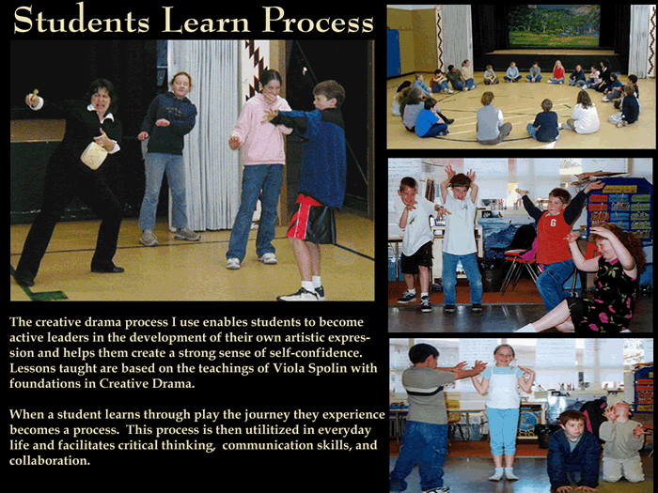
The use of creative drama in the classroom is a student-focused process where experiential learning can be fostered and developed within any given curriculum. It can help students to develop divergent thinking skills, inventive creativity, and cognitive thinking skills, and it can stimulate the development of oral and written communication skills.

Course Objectives
Students will be able to:
- Identify, analyze and actively engage in creative drama exercises and practices.
- Adapt creative drama exercises for specific pedagogical goals.
- Use improvisation exercises in a well-ordered PROCESS that facilitates learning.
- Plan and execute lesson plans.
- Utilize Classroom Management skills and techniques as a component of effective teaching and learning.
- Structure curriculum-based lesson plans in line with the Oregon Department of Education Academic Content Standards.

Students in this course will participate actively in discussions and activities. The class is designed to incorporate reading and some research, but the bulk of the work will be in the activities and the application within a classroom environment.

Grading Breakdown:
Creative Drama Labs
(participation; regular attendance is essential to earn all points) 200 pts
Activity Log Book 200
Reading Logs (50pts/ea) 5 total 250
MidTerm : class presentation of CD activity 150
Final: One Hour Lesson Plan 200
TOTAL POINTS POSSIBLE: 1,000 pts

Extra Credit: TBD 50 pts

Course Requirements
Emailed assignments are NOT accepted ALL ASSIGNMENTS MUST BE SUBMITTED THRU MOODLE
- Attendance: Regular class attendance is essential, as in any collaborative work, missing or tardy participants are highly disruptive. To accomplish the goals of this course, poor attendance and excessive tardiness will be cause for lowering attendance percentage:
Two Tardies and/or Absences - excused providing it does not occur when assignment lab work is due. Each additional absence or tardy will reduce the attendance grading by 5%.
- Creative Drama labs: Active participation is vital. All class time will be used in the developing of skills and creating of lesson plans.
- Notebook: Participants are required to keep a notebook to record the application of games and exercises as demonstrated in class. This notebook will be handed in for grading purposes and then returned to the student so that it can be used as a reference guide. Guidelines and grading criteria will be provided.
- Lead 10-Minute Exercise, Mid-Term: Plan and lead a ten minute, in class creative drama exercise based on materials covered within course work. This lesson can be adapted from previous class demonstrations, other sources or you may plan your own. Guidelines and grading criteria will be provided.
- Reading logs & Discussion: Keeping up with the reading is vital to an understanding of the creative drama methods we will be discussing. Five Reading Logs will be assigned (min 500 word, typed response). Logs will be written responses to materials/articles/chapters located in open educational resources(OER). In-class discussion of text and observations is critical to developing a full understanding of the work – your participation is vital to your grade. The logs must be turned in on the due date, late submissions will be subject to a 10% deduction.
- FINAL One-hour Lesson Plan: The development of a lesson plan that uses creative drama as an instructional tool is a valuable skill. Students will be required to create a one-hour lesson plan focusing on a curriculum unit. One hour of the unit will be dedicated to a creative drama based lesson. (detailed instructions will follow). Guidelines and grading criteria will be provided.
- Extra Credit: Attend LBCC Spring production, write a critique using a provided handout. Free admission if you volunteer to usher, please see me to receive critique form.

Participation & Work Ethic
Participation and work ethic points are earned by being an active contributor and listener. I will assess your participation and understanding in part by observing you individually and in groups.

Materials:
Three Ring Binder
Hand-outs: a loose collection of articles, sample plans, etc. To be distributed in class.

Optional Reading Materials:
Creative Drama in the Classroom, by Nellie McCaslin
Theatre Games for the Classroom, A Teacher’s Handbook, by Viola Spolin
Dramatic Imagination, A Handbook for Teachers, by Jerneral Cranston
Theatre for Young People, A Sense of Occasion, by Helane S. Rosenberg & Christina Prendergast

Students who have emergency medical information the instructor should know of, or who might need special arrangements in the event of an evacuation, or students with documented disabilities
who have special needs, should make an appointment with the instructor no later than the first week of the term. If additional assistance is required, contact LBCC’s Office of Disability Services at 917-4789.

LBCC Comprehensive Statement of Nondiscrimination
LBCC prohibits unlawful discrimination based on race, color, religion, ethnicity, use of native language, national origin, sex, sexual orientation, marital status, disability, veteran status, age, or any other status protected under applicable federal, state, or local laws. (For further information http://po.linnbenton.edu/BPsandARs/ )

Student Decorum Statement: Because college coursework and professional correspondence require focused study and open exchange of ideas, the Department expects the classroom to be a place of interaction, a forum for demonstrating mutual respect between teachers and students. Professional communication requires all of us to listen carefully to each other (whether we agree or not) and to state our positions with clarity and our disagreements with tact. Standards for academic courtesy apply to group work, on-line interaction, and student teacher conferences as well.

Course Policies:
- Email: I will work to respond to emails within one to two BUSINESS days (business days excludes the weekends).
- Assignment Submission: Please type all submissions and proofread carefully. All assignments must be submitted via Moodle
- Attendance: Please attend regularly to receive full participation credit. If you are absent due to illness or a verifiable emergency, you must contact me within 24 hours to make further arrangements. Those who miss more than four class periods within a two week period risk failing the course.
- Late Work: late work will be assessed a 10% deduction prior to grading. Late work is not accepted after week eight.

