Before you start, please:
- Inset the CIS101 class USB Thumb drive
- On the USB root folder/directory, create the CIS101 folder (unless the folder already exists)
- Under CIS101, create Final-Exam-Files folder (unless the folder already exists)
- Use USB-thumb-drive-letter:\CIS101\Final-Exam-Files to store all Final exam files
- Download Final-Exam.docx to Final-Exam-Files folder
- Open the USB-thumb-drive-letter:\CIS101\Final-Exam-Files\Final-Exam.docx file, answer all questions, save the changes to the file, and upload to Moodle.

Q1) (3 points) List the five MS Office 2013/2016 and MS Office 376 products/options (must get at least 3 correct for 1 point and 4 correct for 2 points):
MS Office 2013/2016 and MS Office 365 Products/options

Q2) (4 points) List five MS Office productivity applications (must get at least 3 correct for 1 point and 4 correct for 2 points):
MS Office Productivity Applications

Q3) (3 points) List three mobile Operating Systems one could use the Office Mobile apps from (must get at least 1 correct for 1 point and 2 correct for 2 points):
MS Office Apps Mobile Operating Systems

Q4) (10 points – subtract 1 point for each error) Start MS Word, on the New/Templates screen, click on Blank document and create a file that is identical to the one below (minus the SAMPLE background):
Guidelines:
- Font = Calibri for all
- Font size:
  - Text, in black = 12
  - Page header and footer, in Blue = 14
- Category headers, Header and Footer are bold
- No space between category headers and text
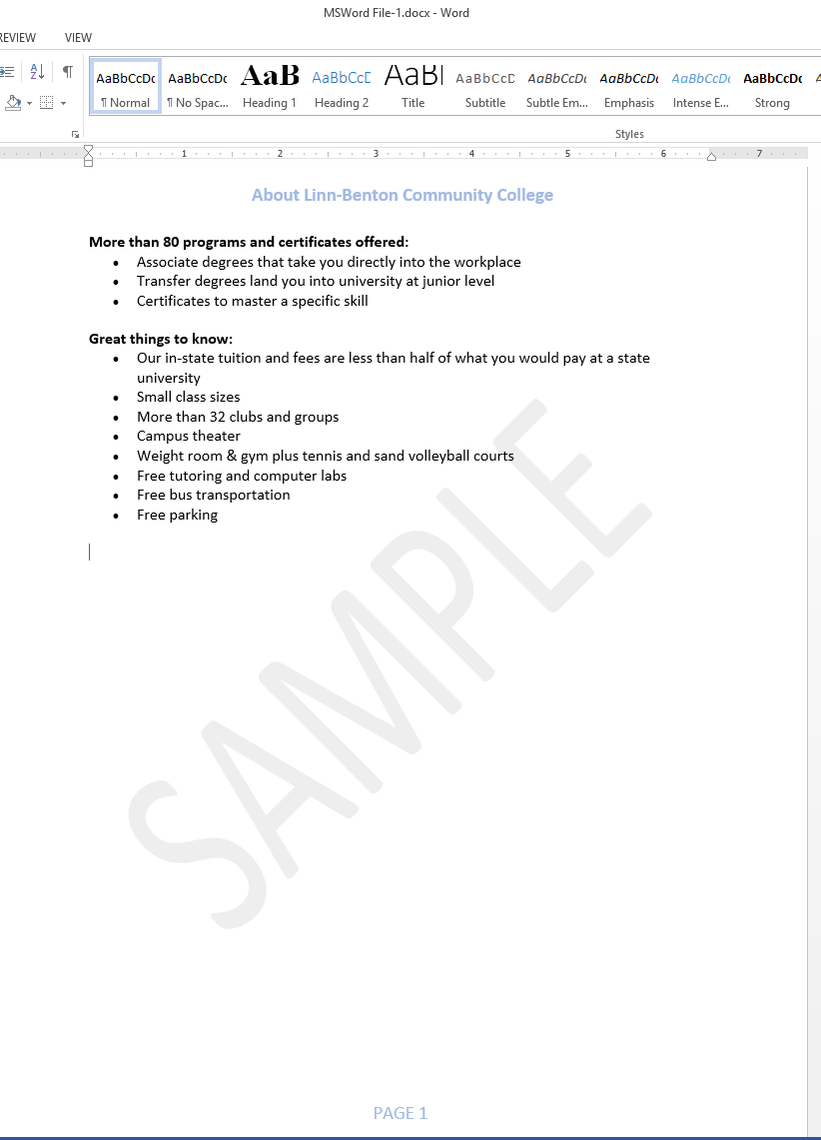
- Save as MSWord File-2.docx in Final-Exam-Files folder
- Snip the file content (including header and footer)
- Save as snip-1.jpg in Final-Exam-Files folder.
Paste-snip-1-here
Q5) (5 points – subtract 1 point for each error) Start Google Docs and produce the same doc as above with same guidelines:
HINT: Feel free to copy-n-paste.
- Create an LBCC folder (unless the folder already exists), and inside the LBCC folder create CIS101 Midterm sub-folder
- Save as GoogleDoc-2 in LBCC\CIS101 Final folder
- Snip the file content (including header and footer)
- Save as snip-2.jpg in Final-Exam-Files folder.
Paste-snip-2-here
Q6) (5 points) Change the GoogleDoc-2 document permissions so anyone on the Internet Can edit the document:
- Right-click on GoogleDoc-1
- Click on Share
- Click on Advanced
- Click on Change under Who has access
- Select On – On public on the web
- From the Access drop-down menu, select Can Edit, then click on Save
- Use the Snipping tool to capture the permission window
- Use the red Pen to circle the document permissions under Who has access
- Save as snip-3.jpg in Final-Exam-Files folder
- From the Link Sharing window, click on Done.
Paste-snip-3-here
Q7) (10 points – subtract 1 point for each error) Start MS Excel, on the New/Templates screen, click on Blank workbook and create a spreadsheet that is identical to the one below (minus the at top-right):
Guidelines:
- Font = Times New Roman for all
- Font size:
  - Steve’s 2016 Expenses header, in black, bold and size = 15
  - Expense category headers and month, in black, bold and size = 12
- Dollar values format = Currency with two decimal points
- Center expense category headers and expense values
- Select similar colors – don’t have to be identical
- Use the Sum function to add the totals
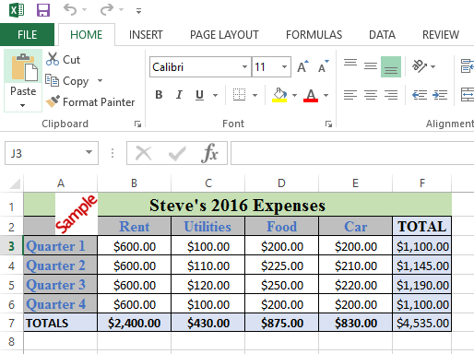

- Save as MSExcel File-2.xlsx in Final-Exam-Files folder
- Snip the file content
- Save as snip-4.jpg in Final-Exam-Files folder.
Paste-snip-4-here
Q8) (5 points – subtract 1 point for each error) Start MS PowerPoint, on the New/Templates screen, click on Blank presentation and create a new file with the following three slides (minus the tiled slide background):
Guidelines:
- Use the Organic theme with the default/first variation
- Make sure to enter the Notes one slide-1
- For the graphics/pictures, search online pictures:
  - For slide-1, search for MS Windows 10
  - For slide-2, search for pros and cons
  - For slide-3, search for two thumbs up
  - NOTE: If you can’t find the exact picture, use a similar picture.

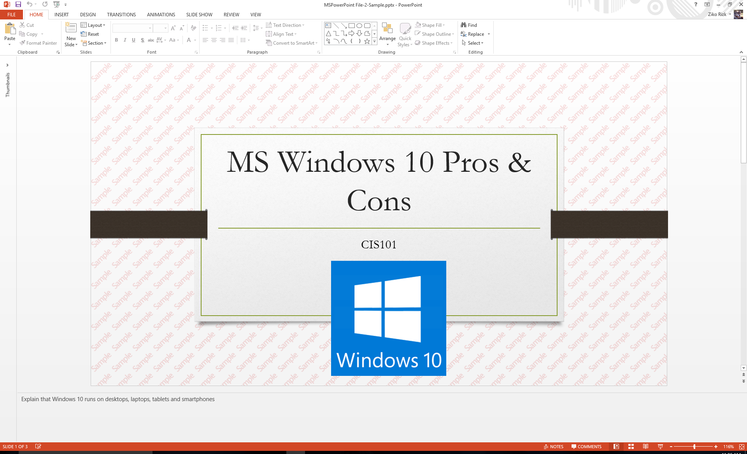

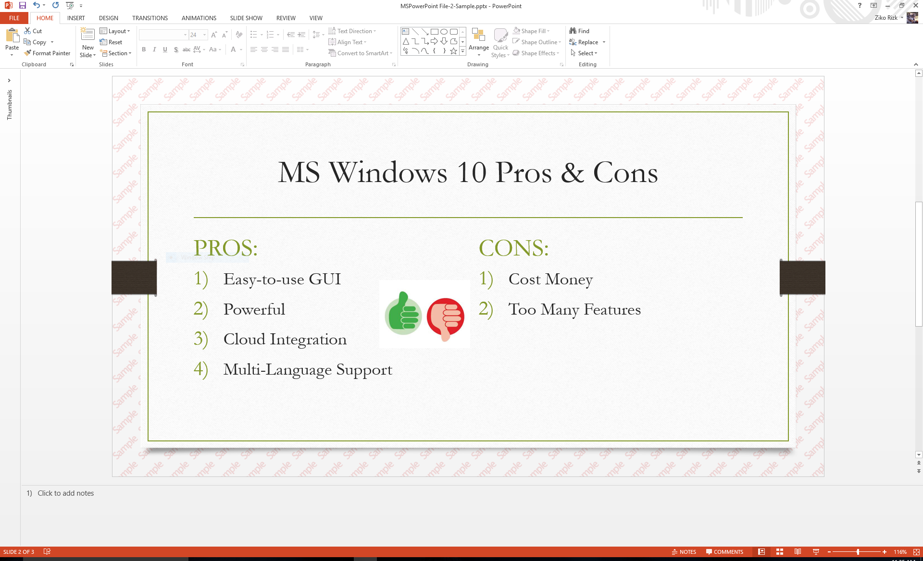

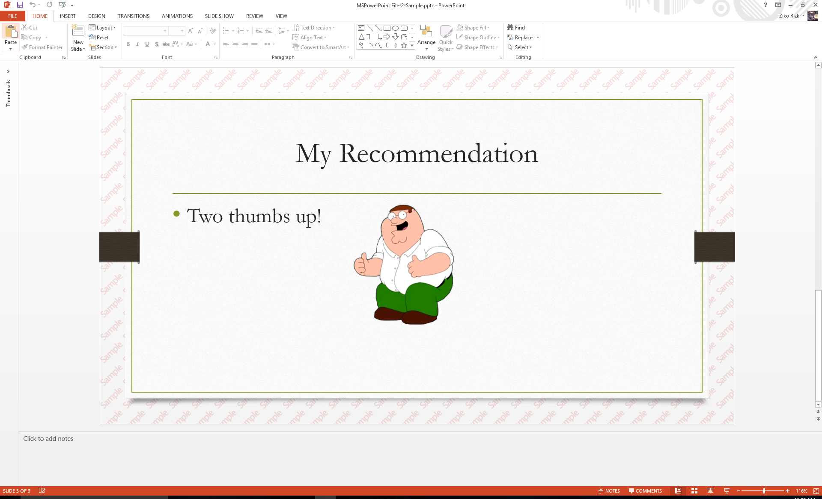

- Save as MSPowerPoint File-2.pptx in Final-Exam-Files folder
- Select the first slide
- Maximize the Slides/navigation pane (manually to enlarge the three slides)
- Snip the entire PowerPoint window
- Save as snip-5.jpg in Final-Exam-Files folder.
Paste-snip-5-here
Q9) (5 points – subtract 1 point for each error) Create the above slides using Microsoft OneDrive PowerPoint:
- Logon to OneDrive using your Microsoft account
- From the navigation pane, click one Files and create \LBCC\CIS101 (unless it already exists)
- From the menu, click on New, then click on PowerPoint Presentation
- Create the above slides using the same guidelines
- Save as MSPowerPoint File-2 in LBCC\CIS101
- Select slide first slide
- Use the red Pen to circle the file name, MSPowerPoint File-2, and the notes at the bottom of the screen
- Snip the entire screen
- Save as snip-6.jpg in Final-Exam-Files folder.
Paste-snip-6-here

