Before you start, please:
- Insert the CS120 class USB Thumb drive
- On the USB root folder/directory, create the CS120 folder (unless the folder already exists)
- Under CS120, create Week6-Files folder (unless the folder already exists)
- Use USB-thumb-drive-letter:\CS120\Week6-Files to store all week seven files
- Download Week6-Assignment.docx to Week6-Files folder
- Open the USB-thumb-drive-letter:\CS120\Week6-Files\Week6-Assignment.docx file, answer all questions, save the changes to the file Week6-Assignment.docx, then zip with MSWord File-2.docx and upload to Moodle.

Q1) (5 points – subtract 1 point for each error) Start MS Word, on the New/Templates screen, click on Blank document and create a file that is identical to the one below. Document guidelines:
- For document Header, select Whisp from Header gallery
- For document Footer, select Blank from Footer gallery
- Font = Times New Roman for all
- Font color and size:
  - Document text: color = black, size = 12
  - Document Header: (Your chosen state/country title) color = black, size 14
  - Category headers: color = Blue, Accent 5, size = 14
  - Page header and footer: size = 12
- Category headers and document Header in bold text
- Write about the State/Country you were born
  - Select 3 facts (Ex: History, Geography, Maps, Economy, etc.) about that State/Country
- Two column layout
- Include at least one picture and one table
- Document must be one page and fill both columns (Points will be deducted for half page document!)
- Save as MSWord File-2.docx in Week6-Files folder.

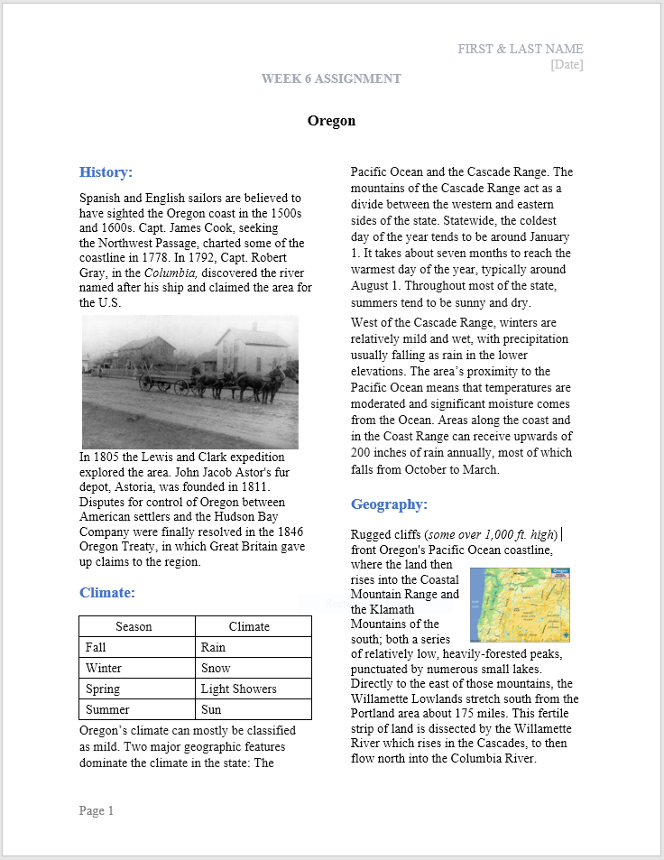

Q2) (5 points – subtract 1 point for each error) Open a blank document in Google Docs and produce the same doc as below with the following guidelines:
- Save as GoogleDoc File-2 in LBCC\CS120 folder
- Create a two-column document about three topics you learned for week 6, include images for each topic and a table to compare the differences. Do not use the sample topics. In your own words, select and write three topics you learned in week 6. Must be one page long and fill both column (points deducted for half page).
- Insert header: Name, date, assignment and course number and name
- Document title (Week 6 Learning Objectives): Font = Times New Roman, size 14, bold, center
- Document body: Font = Times New Roman, size 12
- Paragraph header: Font = Times New Roman, size 12, color = blue
- Insert image (image should relate to chosen topic) in each of the paragraph for the three topics, wrap text and centered in paragraph
- Insert 2x5 table in the differences paragraph. In your own words, list the differences
- Insert footer: page number
- Snip the file content (including header and footer)
- Save as snip-1.jpg in Week6-Files folder
- Paste snip-1.jpg, at the very end, and continue with next step
- Zip both Week6-Assignment.docx and MSWord File-2.docx files
- upload zipped file into Moodle.

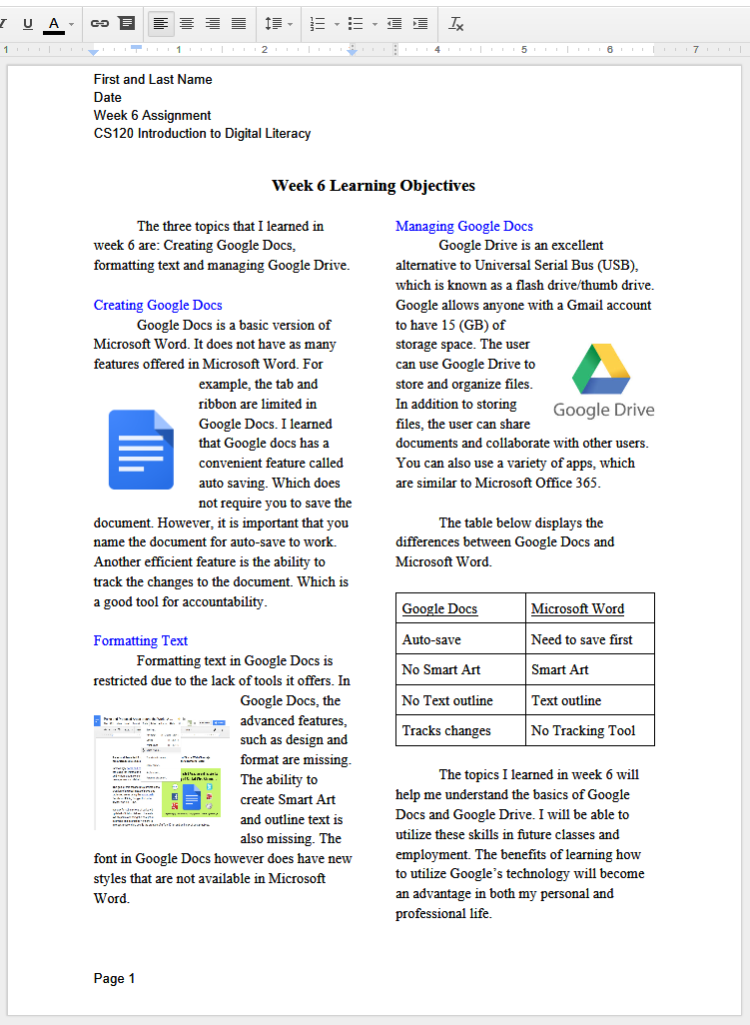

Paste-snip-1-here

